UNITED STATES
SECURITIES AND EXCHANGE COMMISSION
Washington, D.C. 20549
SCHEDULE 14A
Proxy Statement Pursuant to Section 14(a) of the Securities
Exchange Act of 1934
Filed by the Registrant ☒
Filed by a Party other than the Registrant ☐
Check the appropriate box:

☐ | Preliminary Proxy Statement
☐ | Confidential, for Use of the Commission Only (as permitted by Rule 14a-6(e)(2))
☐ | Definitive Proxy Statement
☒ | Definitive Additional Materials
☐ | Soliciting Material Pursuant to §240.14a-12

BIOAGE LABS, INC.
(Name of Registrant as Specified In Its Charter)
N/A
(Name of Person(s) Filing Proxy Statement, if other than the Registrant)
Payment of Filing Fee (Check all boxes that apply):

☒ | No fee required
☐ | Fee paid previously with preliminary materials
☐ | Fee computed on table in exhibit required by Item 25(b) per Exchange Act Rules 14a-6(i)(1) and 0-11

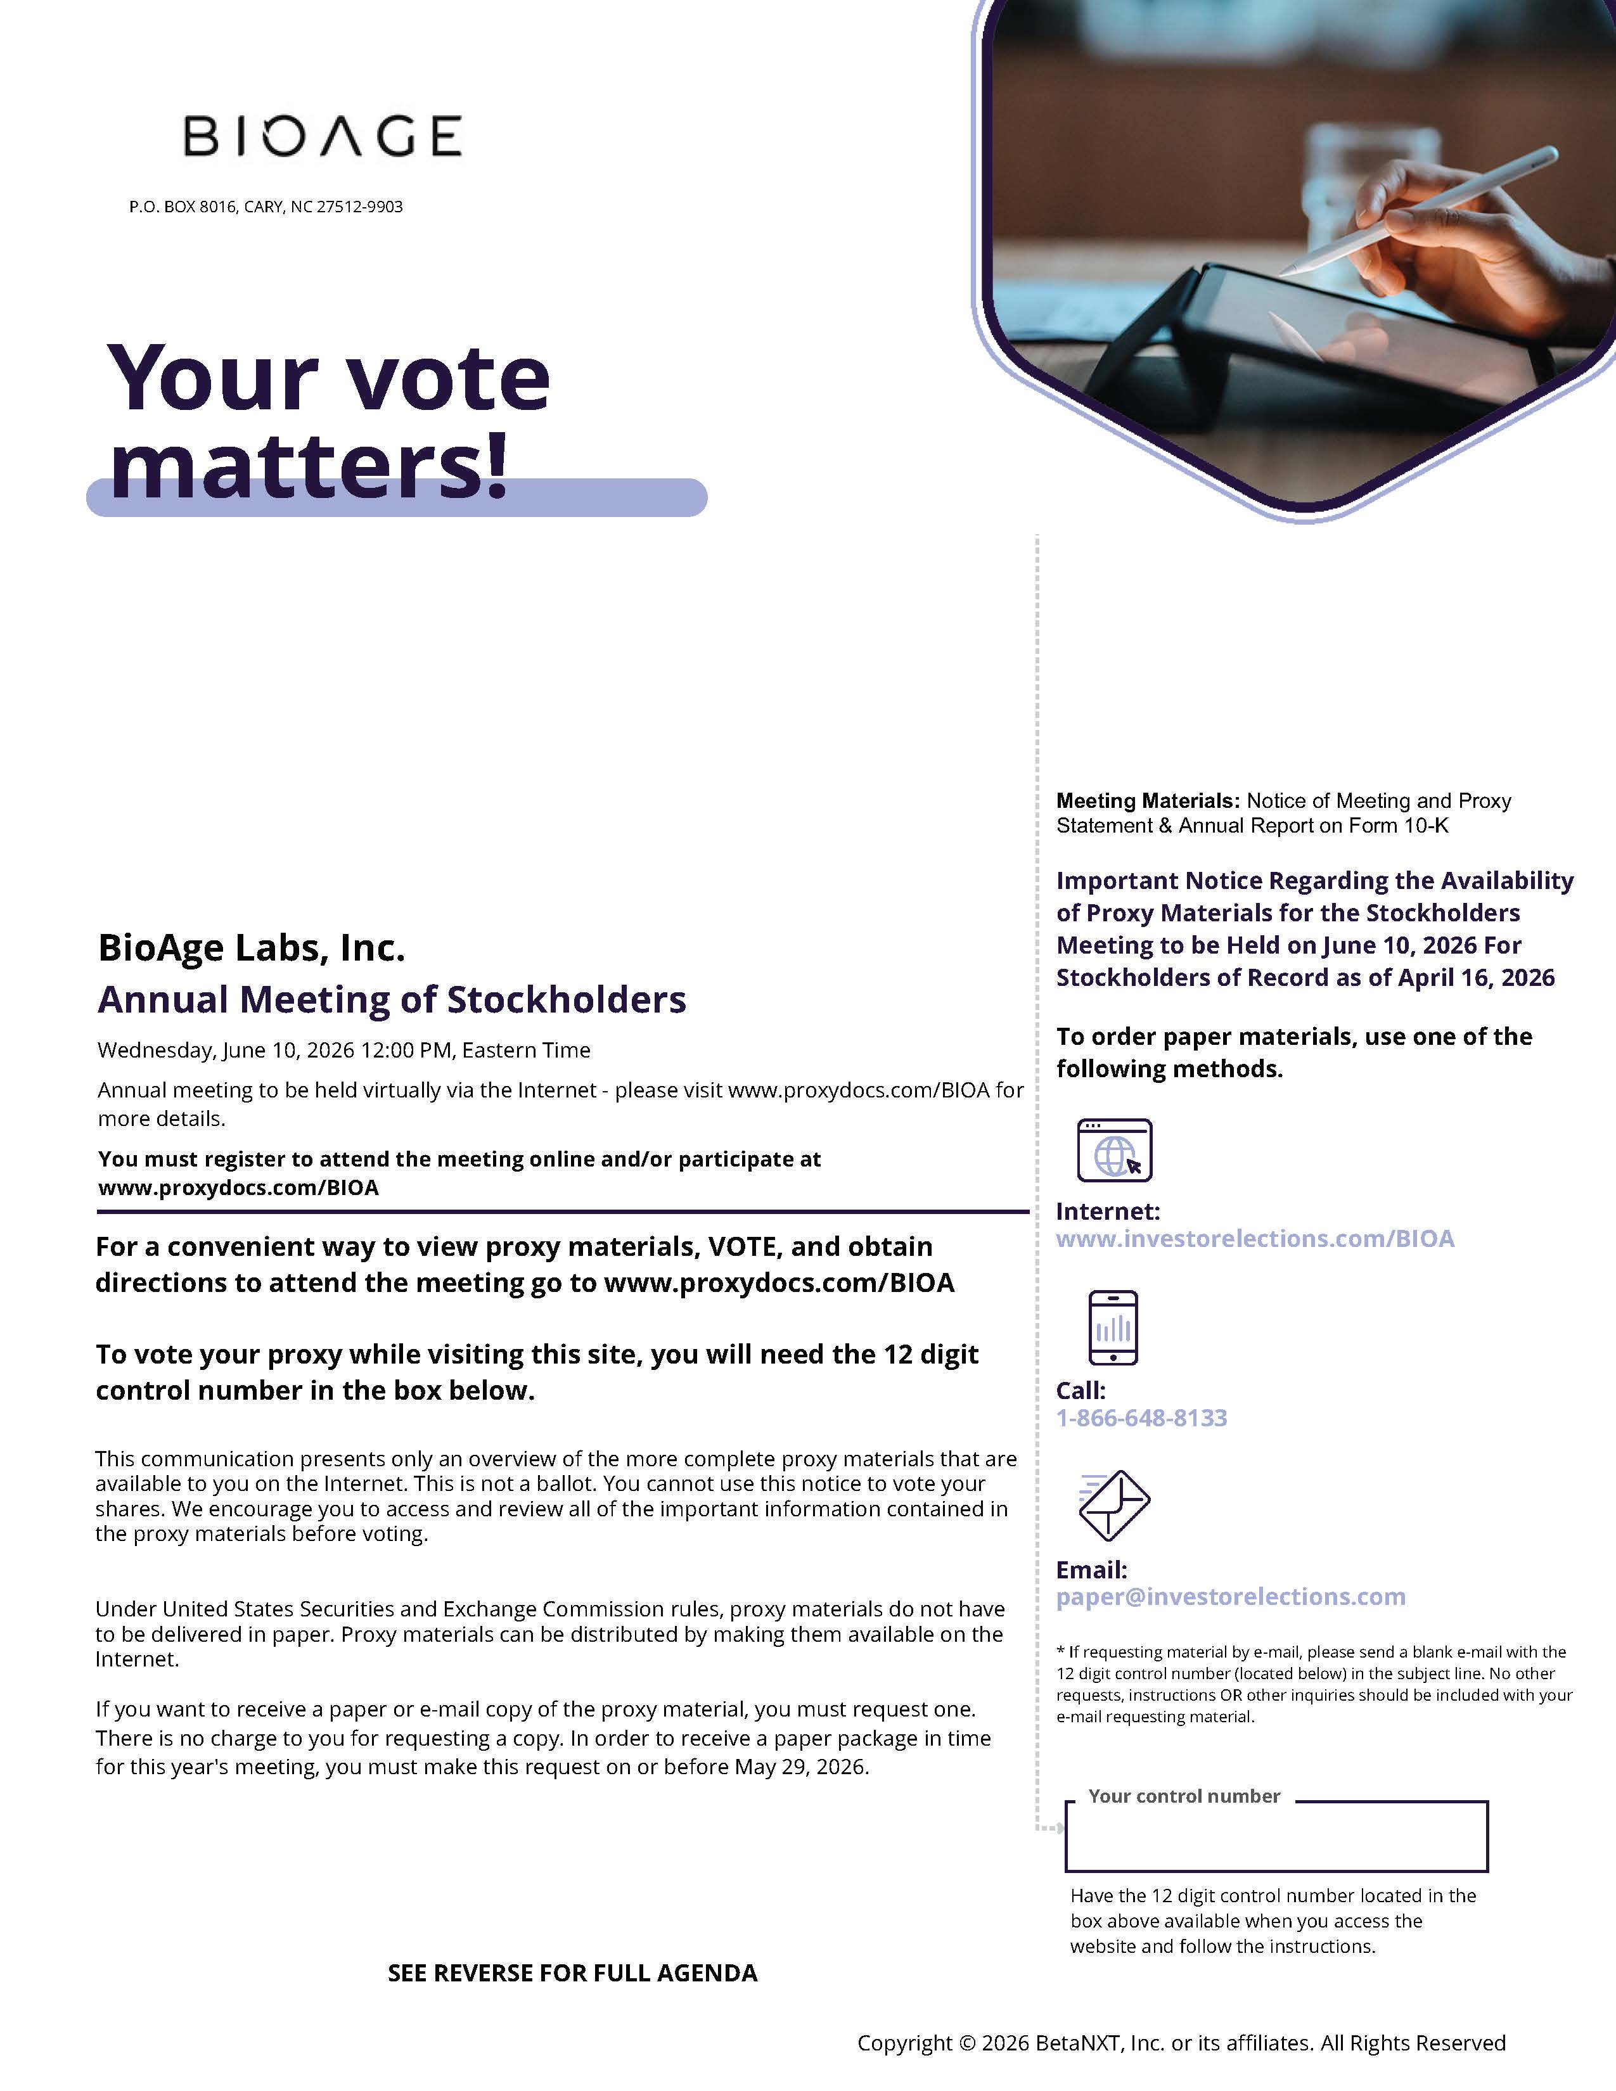

BIOAGE P.O. BOX 8016, CARY, NC 27512-9903 Your vote matters! BioAge Labs, Inc. Annual Meeting of Stockholders Wednesday, June 10, 2026 12:00 PM, Eastern Time Annual meeting to be held virtually via the Internet - please visit www.proxydocs.com/BIOA for more details. You must register to attend the meeting online and/or participate at www.proxydocs.com/BIOAFor a convenient way to view proxy materials, VOTE, and obtain directions to attend the meeting go to www.proxydocs.com/BIOA To vote your proxy while visiting this site, you will need the 12 digit control number in the box below. This communication presents only an overview of the more complete proxy materials that are available to you on the Internet. This is not a ballot. You cannot use this notice to vote your shares. We encourage you to access and review all of the important information contained in the proxy materials before voting. Under United States Securities and Exchange Commission rules, proxy materials do not have to be delivered in paper. Proxy materials can be distributed by making them available on the Internet. If you want to receive a paper or e-mail copy of the proxy material, you must request one. There is no charge to you for requesting a copy. In order to receive a paper package in time for this year's meeting, you must make this request on or before May 29, 2026 SEE REVERSE FOR FULL AGENDA Meeting Materials: Notice of Meeting and Proxy Statement & Annual Report on Form 10-K Important Notice Regarding the Availability of Proxy Materials for the Stockholders Meeting to be Held on June 10, 2026 For Stockholders of Record as of April 16, 2026 To order paper materials, use one of the following methods. Internet: www.investorelections.com/BIOACall: 1-866-648-8133 Email: paper@investorelections.com* If requesting material by e-mail, please send a blank e-mail with the 12 digit control number (located below) in the subject line. No other requests, instructions OR other inquiries should be included with your e-mail requesting material. Your control number Have the 12 digit control number located in the box above available when you access the website and follow the instructions. Copyright © 2026 BetaNXT, Inc. or its affiliates. All Rights Reserved

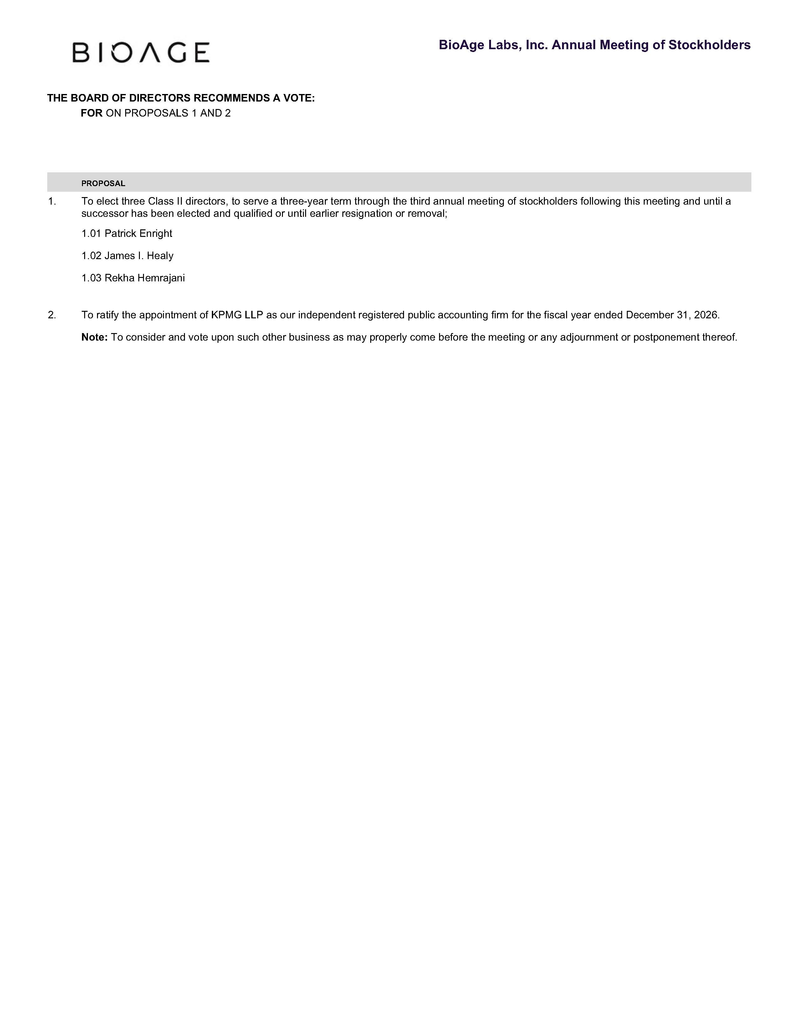

BioAge Labs, Inc. Annual Meeting of Stockholders THE BOARD OF DIRECTORS RECOMMENDS A VOTE: FOR ON PROPOSALS 1 AND 2 PROPOSAL 1. To elect three Class II directors, to serve a three-year term through the third annual meeting of stockholders following this meeting and until a successor has been elected and qualified or until earlier resignation or removal; 1.01 Patrick Enright 1.02 James I. Healy 1.03 Rekha Hemrajani 2. To ratify the appointment of KPMG LLP as our independent registered public accounting firm for the fiscal year ended December 31, 2026. Note: To consider and vote upon such other business as may properly come before the meeting or any adjournment or postponement thereof.

